Chandrayaan-3: Detection and Identification of Exomoons & Exoplanets in the Deep Space using AI

Gautham Gopan1, Benisha M2, Mithileysh Sathiyanarayananan3

*1Department of Computer Science Engineering,**SRM Institute of Science and Technology, Chennai, India*

*2Jeppiar Institute of Technology, Chennai, India*

*3Research & Innovation, MIT Square Services Private Limited, London*

*Abstract*—The launch of the Chandrayaan-3 by ISRO, will certainly aid in the search of exomoons and exoplanets (planets beyond our solar system) that may support life. The integral question, regarding what lays beyond the known horizon has always pondered the curiosity of mankind. This laid the foundation to the search for Exoplanets. With the advancements of both image capturing and telescopic technologies, we have now access to never ever seen before data, which when combined with the processing capabilities of advance AI, paves way to the discovery of newer exomoons and exoplanets out in the deep space. This work mainly focuses on the various techniques that can be used for detection and how their correlations can be better utilized to improve the overall efficiency of the final systems. Also, a list of research questions has been identified for the researchers to work upon.

Keywords—Chandrayaan 3, Exoplanets, Deep space, CNN.

# Introduction

There exists ~~exits~~ multiple different techniques that can be utilized for the detection of exoplanets like, studying the radial velocity of planetoidal objects, observing the inter transmittal shadows of planets and so on. Individually many of these techniques have yielded various significant discoveries, but each of these have their own shortcomings.

The basic concept that is habitualised in these processes is the intercorrelation between the exoplanet and its parent star, it is this data that is being observed and analyzed from different angles from the Earth observation point with different thresholds and parameters that pave way to the above-mentioned methodologies.

Deep space exploration programs have so far resulted in [1] the identification of more than 5514 documented exo-planets and with a significant more number as possible candidates. Various thresholds come into play while deeming a planet as a possible candidate for a viable exoplanet, which includes analyzing the planet's atmospheric properties, orbital properties, proximity to the closest stars and so on. These data points are also taken into account to see if normal life can be sustained on such extraterrestrial bodies.

## The Driving Factor:

The pivotal reason behind the exploration of exo-planets is to seek for existence of possible life beyond our solar system and to also seek for planetary bodies that could sustain life in the future. This search has brought us to finding few such exoplanets that have emulated promising data reflecting their abilities to sustain life. One such planetary body is the Kepler-186f which have showed huge potentials of sustaining life because of its ideal positioning form its host star. Its ideally located in the habitable zone, which is not too close to the host star, but close enough to have atmospheric temperature which is ideal for the existence of moisture. Kepler-186f is also comparable to earth in the terms of planetoidal dimensions which also indicated to the possibility that earth like planets do exist in the deep space and are out there to be explored. Even though the current technical capabilities do restrict us from studying more deeper about the finer details of these exoplanets like their atmospheric configurations and surface integrations, the search for such bodies should be continued on.

The latest advancements in telescopic technologies, with special emphasize to the James Webb space telescope which was launched a couple of years earlier could really help in gathering data regarding the atmospheric compositions of exoplanets. The presence of greenhouse gases like oxygen, carbon dioxide, Nitrogen and so on would give us strong indication of possible life.

## The Relation with SHAPE project

The Chandrayaan-3 module was equipped with a scientific equipment named SHAPE (Spectro-polarimetry of habitable planet earth), which was launched to study Earth form with the lunar orbit. This protocol was designed in such a way that it would mimic the observations of distant exomoons and exoplanets, by considering earth as a possible candidate for observatory purposes.

The key role of the module is to analyze and capture the disc-integrated spectrum of the earth and to analyze the polarization signatures from various vantage points from within the lunar orbit there by observing the variations at different phases. By analyzing the thermal spectra, crucial data regarding how variations in the composition of various atmospheric gases in correlation with the shift in seasons effect the thermal emission spectrum of a planetoidal body can be studied. These variations are more noticeable for readings taken from the either pole of the planet, and the variations narrow down as we focus on the equatorial region. The analysis of such data also gives us insights about the surface features of the planets and this same method was used to characterize the rocky structure of the Kepler-186f exoplanet. The analysis of the polarization signature of a planet helps us to identify the presence of clouds in the upper atmosphere of a planet. Both these process where caried out by the SHAPE module, capturing the data with respect to earth as an exoplanet. The observations would be continued to be made at various orbital positions within the lunar orbit.

The main throughputs from the efforts carried out by SHAPE would be that we would be getting an idea about how the data from an earth-like planet is supposed to look like, answering questions like how the disc-integrated spectrum of an earth like planet would look like and how would be the variations in its polarization. This data can be used for future references while observing distant exo-planets, there by acquiring a referential dataset.

Apart from the process discussed above there are five other common methodologies that are used to identify distant exoplanets, and each have their own advantages and disadvantages. Creation of system that could integrate all these five methodologies would be of great impact to systems like SHAPE for future exploration endeavors.

The paper is structured as follows. Chapter II brief the methodologies followed by the space researchers to detect the exoplanets. In chapter III limitations of the important detection techniques are listed. Chapter IV elucidates the proposed system capable of detecting exoplanets in a more efficient way. Chapter V conclude the work and ideate over the future work.

# Analyzing the Individual Methodologies

## :The Doppler Method

This method works on the principle that gravity acts both ways, the stars are also under the influence of the gravitational pull of the planets around them, and this happens when both the star and the planet revolve around a fixed center of mass. This gravitational pull results in a slight wobble induced in the stars movement and by observing this wobble of the star it can be deemed that it plays host to a nearby exoplanet, this becomes extremely critical as often the brightness of these stars often envelops the ability of telescopes to identify exoplanets near their vicinity.

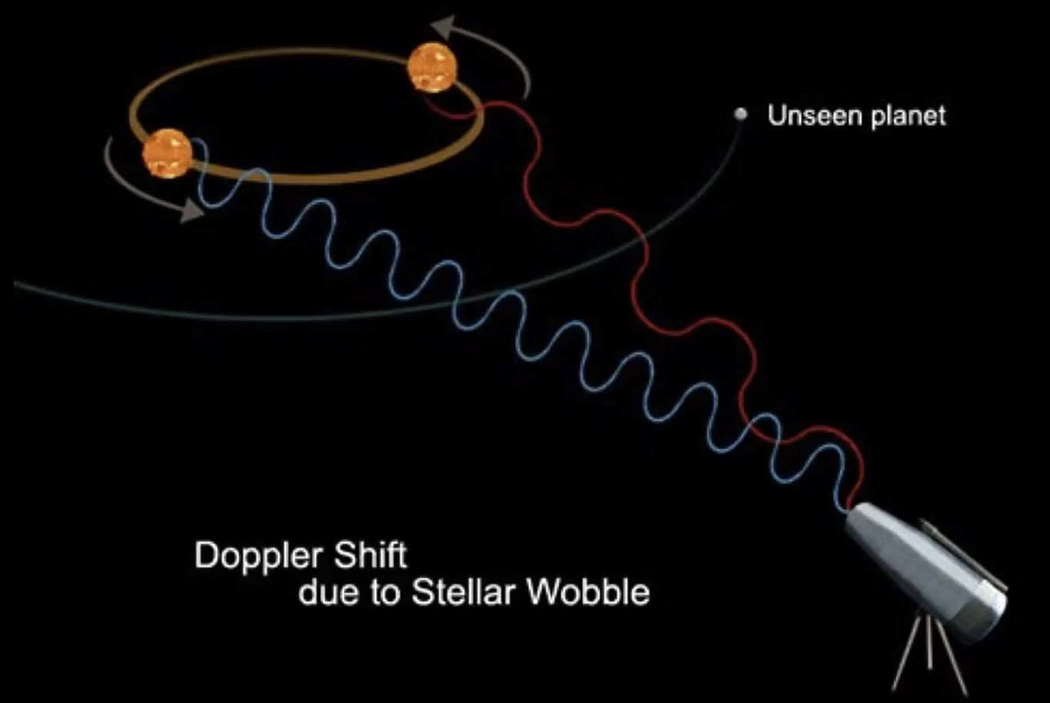

1. Doppler Method

The star takes the exact amount of time to complete a full orbit as the planet and therefore by measuring the stars period we can also calculate the period of the planet near them. By using the Kepler’s law, we can calculate the distance between the planet and the center of mass of the system, if the planet is really heavy the center of mass will be a bit closer to it, which means that the radius of the stars orbit is bigger. If the time taken to complete the orbit is still lesser, it means that the star is moving at a much higher speed, so thereby by measuring the speed of the star we can calculate the mass of the planet. All these data regarding the velocity and radial path needed to predict the mass of the planet can be gathered by using the doppler method. This method can be used to measure the stars velocity. When observing a star in deep space, it either feels as if the star is moving towards, the observatory point or away from it. By analyzing the spectrum of the light as demonstrated in Fig 1 that reaches us, it can be observed that when it seems to be moving towards the point the spectrum is blue shifted and it appears to be red shifted when it moves further away. By measuring how shifted the light coming from the star is, it can be concluded when the star is able to complete a full orbit, thereby providing us the period.

With respect to the earlier relation that, heavier the planet the faster the star’s velocity and thereby more vivid their spectrum is, this is why heavier the exoplanets are, the easier they are to be discovered.

## The Transit Method:

This method works on the principle that if a planet is orbiting around a star at a fixed angle and orientation with respect to the center of mass of the existing system, then the planet is supposed to cross in front of the star during its transition through its orbit. During this process if the light coming from the star is under observation, slight variations in the brightness level will be evident. This variation in brightness if observed over a period indicates the presence of an exoplanet in the observed system. This phenomenon can be compared to what happens during a lunar eclipse when the sun’s light is partially disrupted by the moon. This one of the most successful methods yet in detecting exoplanets.

By using this method, the radius of the exoplanet can be calculated by subtracting the area of light that is being dimmed out from the overall area of the light source. In mathematical terms this can be deduced as the change in flux (, or the brightness of the star is equal to the square of the radius of the exoplanet ( divided by the square of radius of the star (. That is,

(1)

By rearranging this equation, we can calculate the radius of the exoplanet by knowing the amount of brightness reduced and the radius of the star.

## The Direct Imaging Method:

Majority of the exoplanets that we know today have been identified using the above mentioned two techniques, irrespective of that fact with the advancement of telescopic and advance imaging methods newer ways of exploring such distant planets are being developed, one such method is Direct imaging. In accordance with all the planets in our solar system, which do not produce any light of their own, but rather reflect the light of their star. Similarly, exoplanets also reflect the light of their stars, this light can be detected by taking direct images of such planets, but unfortunately due to the huge glare generated by the stars, the light reflected of these planets often go unnoticed. This is where the application of a coronagraph comes into play, this device help in blocking much of the glare of the parent star, making light reflected of the planets more visible during direct imaging. The planet 2M1207B, which was found orbiting around a brown dwarf star was the first exoplanet to be found by using this method. The only hindrance to this method is often while attempting to block out the glare of the parent star, the reflected light of from the planet also gets engulfed in the spectra of the coronagraph.

Direct imaging can also be used to analyze and monitor the orbiting of the planet around the parent star. The further advancements in this technique will aid in understanding more deeper about the atmospheric patters, presence of oceans, and even land masses on these exoplanets.

## Gravitational Microlensing Method:

This concept works on the principle that a heavier star or planet bends the space fabric around it causing the light that’s passing through their system to be brightened for a period of time, this variation can be noticed as a small blip in the brightens graph of the observed star. To be able to uses this technique the light coming from the distance star need to magnified and this happens when a smaller star system comes in between earth and the larger star under observation. In most scenarios the star under observation would be larger and easily noticeable form earth and the system in between might be having a smaller star that might not be visible from earth.

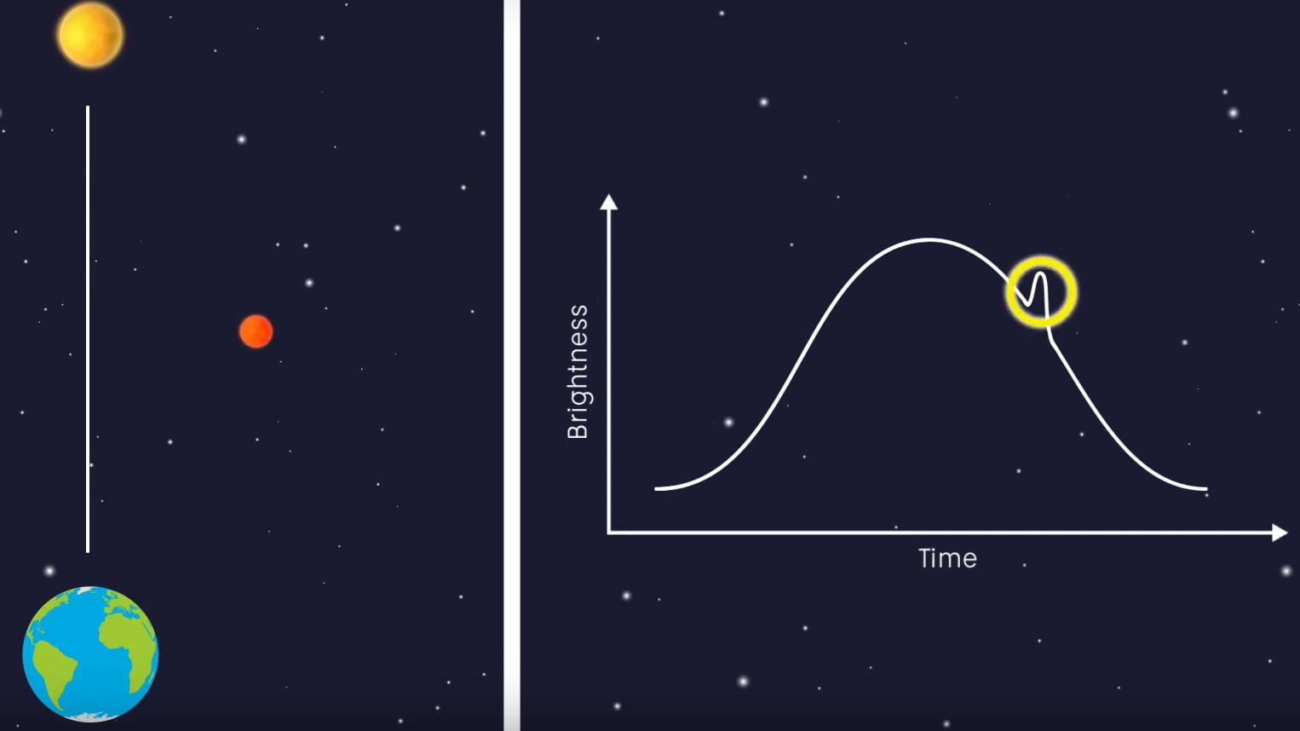

1. Variation in brightness

When the smaller star passes in between the earth and the larger star, the light from the larger star gets bent by the gravity of the smaller star resulting in two versions of the larger star as seen from the point of view from earth. This indicates that the gravity from the smaller star is producing an effect that is very similar to a lens, which magnifies the larger star when the small star passes in front of it, this results in the change of brightness intensity in the Einstein cross, and it will be at its brightest when both the stars are aligned with each other. If there is planet in the same system as the smaller star, then the mass of the planet adds to the lens effect created by the system and thereby increasing the modulation in the brightness of the larger star. This induces a small blip as noticed in fig 2 in the overall readings indicating the presence of an exoplanet.

This can be helpful in identifying planets that are far away from their parent stars and also aids in the discovery of smaller exoplanets and even exomoons orbiting such exoplanets. The lensing phenomenon can often be noticed regularly but the blip phenomenon often happens instantaneously and had to be monitored regularly over a period.

## Astrometry Method:

This method works on the same principle as that of the doppler effect, that the stars wobble minutely under the influence of the gravity of the planets around them. But unlike in the previous methodology where the spectrum is used to identify and study this wobble, here Astrometry is made into use. The science of precisely measuring the position of an object in the sky, by making use of reference points is called Astrometry. When observing a target star, which could support a system that has an exoplanet in it, the position of the star is marked with other referential stars in the broad skyline, and the distance from each of these reference stars to the target star is measured and monitored continuously. By analyzing the variation in these distances with respective to the relative position of the target star the wobbling effect can be detected and thereby indicating the presence of exoplanet in the system. This detection would require the use sharp vision and extremely powerful telescopes as the variations induced are extremely minute especially in the case of smaller exoplanets.

The method makes use of extremely advanced optics and requires precise adjustments within the used instruments clusters. This method is harder to execute from the earth’s surface due to the hindrances caused by the upper atmosphere, which may result in the collection of corrupted data. This methodology can also be heavily improved with the advancements in telescopic and optics technologies. This could have also been a powerful addition to the SHAPE module as the Lunar orbit would have been the right environment to implement this methodology due the versatility provided by open space and the lack of hindrances.

## Transmit Variations Method:

With respect to the above-mentioned methodologies, which are more focused towards the detection of exoplanets, this method aids in the detection of exomoons. The detection of such planetary bodies play a crucial role in the discovery of self-sustained planet formations, [2] these giant planetary satellite’s contain detailed data points regarding the thermal and compositional properties in the early circumplanetary accretion disks. There are mainly two variations that are analyzed in this method one is the Transmit timing and the other is the transmit duration, by gathering the relevant datapoints that captures the time these exomoons take to complete one full orbital circumnavigation and the duration between each subsequent crossing helps us to identify the sense of orbital motion(SOM) of the targeted exomoons.

Although these variations are extremely hard to detect because of extremely minute changes in the detected data readings, the advancements in the image processing techniques proposed can play a major role detecting these data points. Identification of such space bodies will play a major role in the identification of self-sustained planetoidal systems which could possibly be exhibit the same properties as the interconnection between Earth and its moon.

# Drawbacks with the porominent methods

## The spatial Orientation:

From the point of observation, the angle at which the target system is observed plays a very crucial role in the identification of exoplanets. In many scenarios due to inappropriate orientations of both the observation units and the targeted system results in the gathering of corrupt or incomplete datasets. This is one of the pivotal reasons that hamper the efficiency of the radial velocity or the doppler effect method, as the observation of the spatial spectrum is hugely dependent on how the targeted system is oriented with respect to the point of observation.

The analysis of the wrong spectrum variations will give result in the predicted radial velocity of the star to be inconsistent which would eventually lead to the wrong calculation of the mass of the exoplanet, or in the worst scenario even led to not even detecting its existence.

## Increased dependency on the host star:

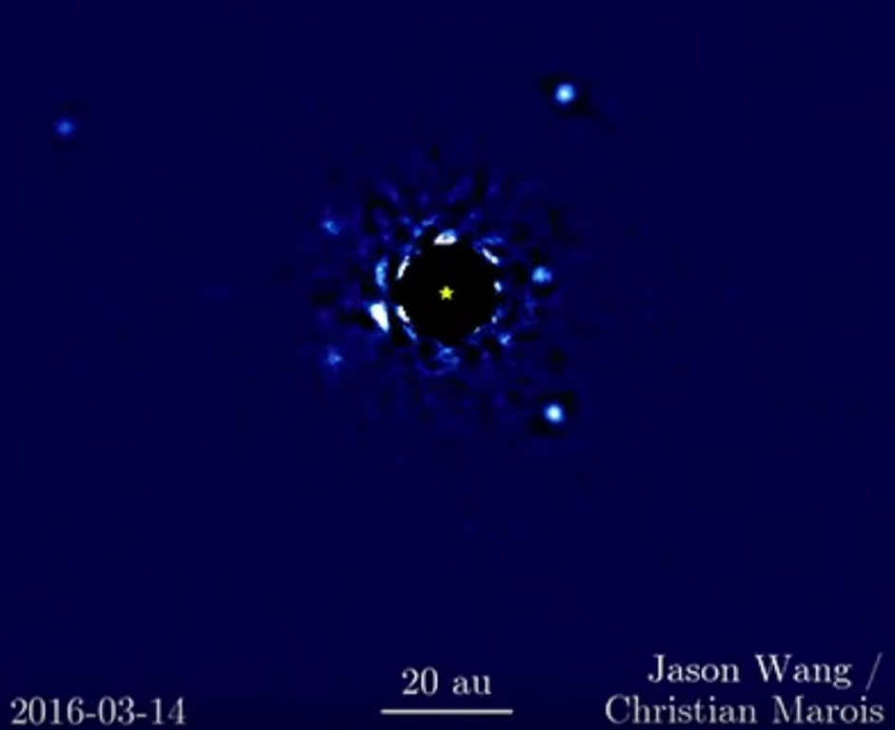

1. HR8779

A significant number of exoplanets that have been discovered so far are all in close proximity to their host stars. For instance, as seen in Fig 3, the young star HR8779 had four identified exoplanets orbiting in its system, but this does not rule out the possibility that it only supports these four planets. There might be planets that are further away from the star and might have been missed out during the direct imaging process which led to the discovery of the remaining four, this explains the dependency on the host star for the detection of exoplanets. Even though the stars play a major role in the identification of exoplanets, they are also the reason why many go unnoticed.

In methods like direct imaging the glare produced by the host star often blinds the region around its close proximity, often resulting in exoplanets near the star to go unnoticed. Even though advancements in star shade and optical lensing can bring improvements in these forefronts, the results are still being crimpled by various other supporting factors. With respect to the microlensing method, the ratios between the size of the observed star and the targeted star plays a critical role in identifying exoplanets in the targeted star’s system, if the targeted star is too small or too large it might hinder the lensing procedure that will take place, thereby causing disruption.

## Variations with the positioning of the observation point:

Having observation points on the surface of the earth and out there in the open space have its own advantages and its drawbacks. Having system down on earth provides the versatility to use heavier and more sophisticated observation machineries like larger optics and star shades. Hoverer this is again contradicted by the interference of the earth’s atmosphere during the observation part. The various gaseous compositions spread out across the atmosphere cause variations in the light spectrums observed from distant stars. This is one of the main reasons behind the failure of the doppler effect as the spectrum gets heavily disrupted leading to false readings.

This one of the major reasons why the SHAPE module was deployed in the lunar orbit as that gives the entire system a way better vantage point in making observations, as there is very little hindrances from external sources. The only downside of an observation point out at space is the extreme modularity that the system should possess and the restrictions in its mass and size limits the capabilities of the technical hardware that can be compressed into these modules. The optical instruments used for deep space explorations have larger apertures which make them extremely hard to be integrated into these outer space systems and the strict weight restrictions on the delivery payload also puts restrictions on how these systems are designed.

# The Proposed System

With respect to the discussions regarding the various hindrances and backdrops faced by the above-mentioned methodologies, its proposed to create a system that would integrate all these five methodologies and use them in tandem. The creation of such a system would require both advance software and hardware components to be packed into a payload that could be successfully delivered to the outer space.

## Advanced CNN based image analyzers:

The images captured by direct imaging can be better analyzed by using specially weighted networks using the data captured by the SHAPE module as a point reference the weights of the neural network used to analyze these images can be preset to give it better chances for the network to identify possible exoplanets form these images. Having a reference dataset to train the model on what to look for can go a long way in increasing the overall efficiency of the system.

By using the least-squared optimization, grid-search, or matched filter approach, we can analyze the spectroscopic characteristics of an exoplanet. One of the biggest challenges faced by the current algorithms in use are the presence of extremely noisy photometric datasets. The lack of proper training datasets also plays a crucial role in the same.

## Detailing the Neural Network:

In order to train the deep neural networks to correctly predict single planetary transits in noisy photometric data, training data is simulated. The generated data is remarkably similar to what is to be expected to learn from a real planetary search survey. This network can be then used to assess the likelihood of the presence of potential planetary signals in data that it has never seen before after the deep nets have been trained.

The photometric measurements obtained from the light curves are correlated with one another at different times. To derive local features from time-ordered input data, we can use convolutions. One way to think about generating new inputs via convolutional neural networks (1D CNN) is to apply a specific filter to the data before feeding it into the network. The weights of each filter are tuned similarly to a fully connected layer. This can quickly increase the number of model parameters that can be trained by using fully connected layers, where each input piece of information for each neuron is assigned a specific weight. Convolutional Neural Networks (CNNs) are capable of computing the local attributes of data using subsampling and convolution when the data is correlated with each other.

The average pooling layer behaves in a way that is comparable to binning observations over time. The max pooling layer, which we tried as well, was designed to select the largest value among bins of three, but we discovered that it was less accurate than an average layer. Convolutions have been used in planet detection techniques in the past through a matched filter approach; however, the filters have been hand-designed, and only one is used. Four filters make up our CNN 1D, and each filter has six weights that have been fine-tuned using the training data.

Any deep net that uses a large number of weights may end up with a non-convex loss function, in which case there would be multiple local minimums. Therefore, the accuracy of the validation may vary significantly because there are numerous possible initializations for the random weight. Our deep learning algorithms' accuracy variations are on the order of 0.1 percent, which suggests that the SGD (Stochastic gradient descent) solver we use is trustworthy.

To summarize the most common methods used for locating planets involve using a least-square optimization, grid-search, or matched filter approach [3], these methods aim to maximize the correlation between the data and a simple transit model.

A least-squares optimization seeks to minimize the mean-squared error (MSE) that results from comparing data and a model. A box function is used to create a simplified model of the transit process because it is impossible to predict the transit parameters in advance. Least-square optimizers are prone to finding local minima when attempting to minimize the MSE, which could result in inaccurate transit detections unless the global solution can be found. Least-square optimizers are susceptible to local minima discovery.

## Handling the SNR:

When individual transit depths are below the scatter, as they currently are for Earth-like planets, constructive binning of the data may improve the signal-to-noise ratio (SNR). Grid searches use binning by performing a brute-force analysis over a range of periods, epochs, and durations to look for transits using either the matched filter or least-squares method. This analysis is performed to identify transits. A matched filter technique attempts to enhance the quality of the signal generated by a transit by combining the data with a specially designed kernel or filter that highlights the characteristics of the transit.

## The Framework:

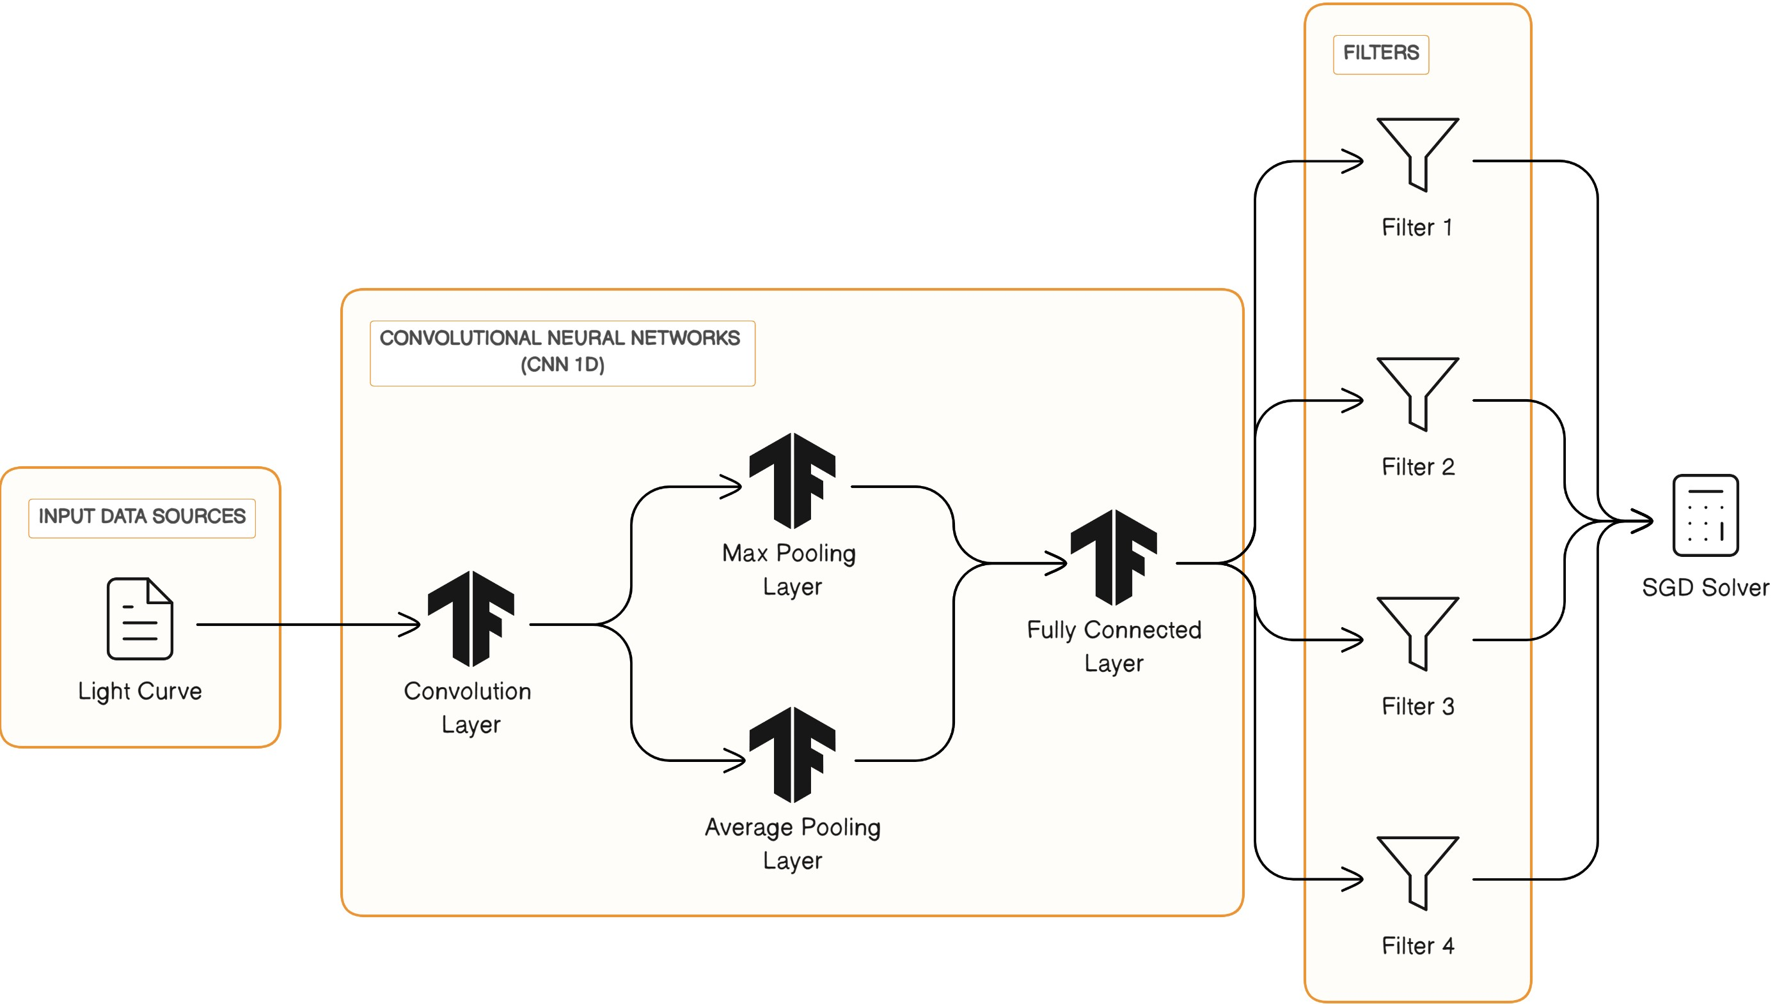

1. Neural Framework

The system is fed with the incoming light cure data with respect to the spectrum analysis done by the optical systems. This input data source then is processed by the CNN 1D as demonstrated in Fig 4. This initially starts with the convolutional layer which then breaks the analyses to the max pooling layer and the average pooling layer. Once both these entities are done with their processing the data is then flown into the fully connected layer. The adjusted weights as discussed in the descriptions above will come into play from the next layer, which also contains a series of filters which would also help in further reducing the signal to noise ration of the overall systems.

The sensitivity of the deep net in the context of the next-generation planet survey by using the expected photometric accuracy of TESS (Transiting Exoplanet Survey Satellite**)**. With the goal set to finding planets similar in size to Earth. When calculating the transit depth, we use the assumption that the star is of the G type and has the same radius as the sun. Our values impose a lower limit on the transit depth and, as a result, the detection accuracy; this is the case even though TESS will focus mostly on M dwarf stars. The CNN 1D algorithm can reliably identify a single Earth-like transit in bright stars with a V value of 8 or above, but it will need to bin the data in order to achieve a higher signal-to-noise ratio for fainter stars.

The planet identification rates, which include the use of 1D convolutional networks and feature modifications like wavelets, and a considerable improvement using CNNs was observed. The methods of machine learning give an artificially intelligent platform that, in comparison to a person, is able to acquire nuanced characteristics from massive data sets in a more time and effort-effective way. The next generation of data processing automation will be more adaptable, capable of   
self-learning, and able to optimize itself with little to no supplemental human input. A qualitative pre-selection will be made, and then a quantitative characterization of the exoplanet signal will be performed when the computer has gained an understanding of what it is seeing.

## The Hardware Developments:

One of the most notable advancements in this forefront is the miniaturization of technical component’s, which makes it now possible to include more scientific modules into a single payload. This miniaturization is done in such a way that it does not affect the overall efficiency of the intended systems. The modularity of such equipment’s also improves their versatility, this can be even noticed in the SHAPE module which in simple terms only consists of three modules namely, the optics part which is oriented to the Earth-viewing axis, the electronics module and the RF source. Modern-day telescopic satellites are also enabled with retractable star shades and, adjustable aperture lenses which improve their data collection abelites.[4] The SHAPE employs an Acusto-Optic Tunable Filter (AOTF) based dispersive element driven by a radio frequency (RF) source, and a pair of Gallium arsenide (InGaAs) detectors. For the light detection systems an updated device called a [5] charged coupled device, which is composed of a grid of independent semi-conductors, highlighted as pixels.

The advancements in the coronagraph instruments has gone a long way in creating star shades that are large enough to block the glare of star but is also now equipped with its own propulsion systems, which enable it to be deployed away from the observatory system and to position its self in between the star and the system in such a way that the maximum amount of possible glare is blocked out. Analysis of origami-engineering can enable designers to come up with new designs that could be even more smaller during the transit period and open up to be larger structure as per the need of the situation.

Apart from these advancements in image capturing technologies and astronomical camera systems have also gone a long way. The Vera C. Rubin Observatory currently holds the largest optical telescope, which is powered by an astronomical digital camera that has 3.2 gigapixels enabling it to have the largest single field of view currently. Having the capability to move on its axis at a rate of 10 degrees per second, this observatory is capable of capturing the night sky of the entire southern hemisphere in under 72 hours.

# Conclusion and future scope

Encapsulating all the key points that has been discussed and pondered upon for this paper we have arrived at the following conclusions and future scope.

## Importance of Deep space Exploarationt:

Through the phases of development of mankind, the single most important question raised was regarding the existence of life beyond our planet and identification of numerous exoplanets will bring us closer to answering this question and also finding a suitable alternative to earth.

## Efficiency and Efficacy:

With respect to the methodologies discussed in this work, the proposed system would be able to solve the current hindrances faced by the individual ideologies by incorporating all of them into a single system where the gaps in the dataflow from one threshold would be substituted in by the other.

## Affordability / Cost Effectiveness:

In accordance with the current scenario, the proposed systems are very well capable of working with the currently available telescopic and satellite technologies they by inducing less cost factoring. Nevertheless, the proposed advancements in hardware components would require adequate amount of funding. The further development can also aid in [6] Orbital debris removal programs, which include the removal of abandoned non-functional satellite’s, and fragment’s which may no longer be of aid to the detection programs, and are creating serious space contaminations and also a hefty cost-factor.

## Flexibility and Robustness:

As discussed in the work the integration of the proposed system would be less cumbersome as the data needed can be obtained by existing spatial and land-based observatory systems. Furthermore, the advancements of the existing hardware solutions will also pave way to acquiring more viable datasets.

As part of this study, we have identified several research questions that has opened up for the researchers to work upon.

1. What machine/deep learning algorithms and techniques are most effective for detecting exoplanets in noisy astronomical data sets?
2. How can AI models be optimized to improve the accuracy and speed of exoplanet detection in large-scale space surveys?
3. Can AI-based methods help distinguish between different types of exoplanets, such as rocky, gas giants, or potentially habitable ones?
4. What data preprocessing and feature engineering methods are essential for enhancing the performance of AI models in exoplanet detection?
5. How can AI be applied to real-time monitoring of exoplanetary systems to identify changes in planetary atmospheres or orbits?
6. What role can generative models, like GANs (Generative Adversarial Networks), play in simulating exoplanetary atmospheres for comparative analysis with observed data?
7. How can AI assist in the detection of exomoons orbiting exoplanets, and what challenges does this present compared to exoplanet detection alone?
8. What are the ethical implications and potential biases in using AI for exoplanet detection, and how can these be addressed?
9. How can AI be used to optimize the scheduling of observations for detecting exoplanets and maximizing data collection efficiency?
10. Can AI assist in the identification of potential candidate exoplanets for further study with ground-based or space telescopes?
11. How can AI models take advantage of multi-wavelength and multi-instrument data for more accurate exoplanet detection and characterization?
12. What are the limitations and uncertainties associated with using AI for exoplanet detection, and how can these be quantified and minimized?
13. How can AI-driven data analysis contribute to the discovery of exoplanets in unconventional or hard-to-detect scenarios, such as binary star systems or highly eccentric orbits?
14. What computational and hardware resources are necessary to implement AI-based exoplanet detection methods on a larger scale, and how can these be made more accessible?
15. How can AI help identify potential habitable exoplanets and narrow down candidates for future astrobiology missions?

Through the various studies and background research conducted, it is clear there is a huge scope for developments in the field of deep space explorations aided with the continuous development in the hardware and technical aspects associated with it. Research has to be done on ways to reduce dependency on the host star of the system. Most of the exoplanets found till date are always found at and adequate distance from their host star neither too far nor too close, this phenomenon results in a lot of celestial bodies which could be possible exoplanets being gone unnoticed.

##### References

1. Exoplanet Exploration: Planets beyound Our Solar System, NASA
2. Ren´e Heller and Simaon Albrecht,2014: How to determine an Exomoon’s sense of orbital Motion.
3. Kov'acs et al. 2002; Jenkins et al. 2002; Carpano et al. 2003; Petigura et al. 2013
4. Chandrayaan-3 SHAPE by U R Rao Satelite Centre
5. Baranne, A., Queloz, D., Mayor, M., Adrianzyk, G., Knispel, G., Kohler, D., Lacroix, D., Meunier, J.-P.,Rimbaud, G. & Vin, A. (1996), ‘ELODIE: A spectrograph for accurate radial velocity measurements’Astronomy and Astrophysics Supplement Series 119(2), 373–390.
6. Thomas J. Colvin, John Karcz, Grace Wusk, Cost and Benefit Analysis of Orbital Debris Remediation